Download Flow package BullsandCowsFlow_20200524060813.zip to your computer.

Go to: flow.microsoft.com within your organisation. Under *My flows* from the menu click *Import*

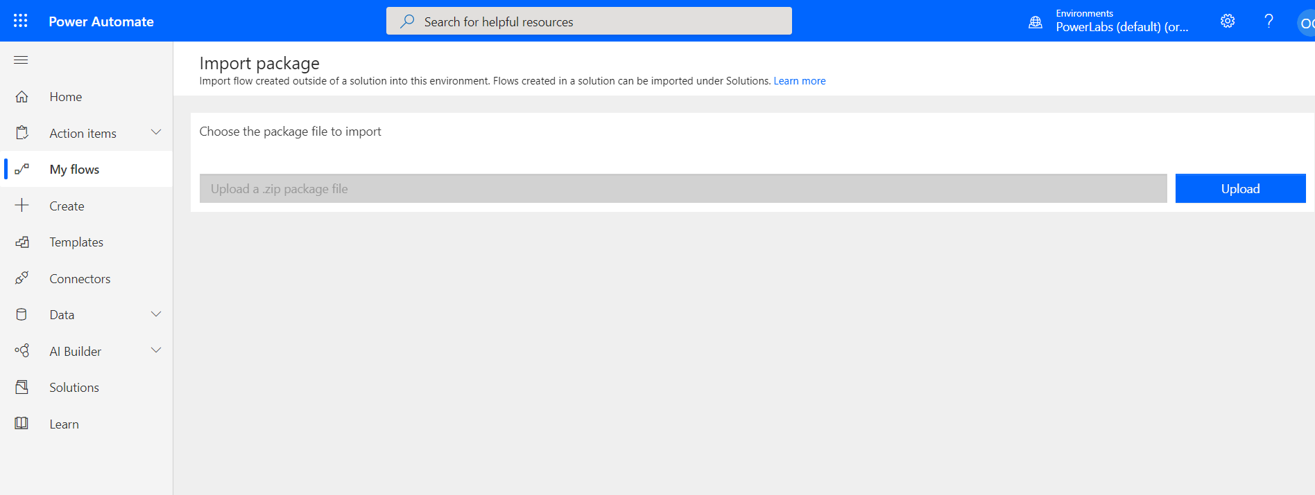

Click on *Upload* to select the package. Then click *Import.*

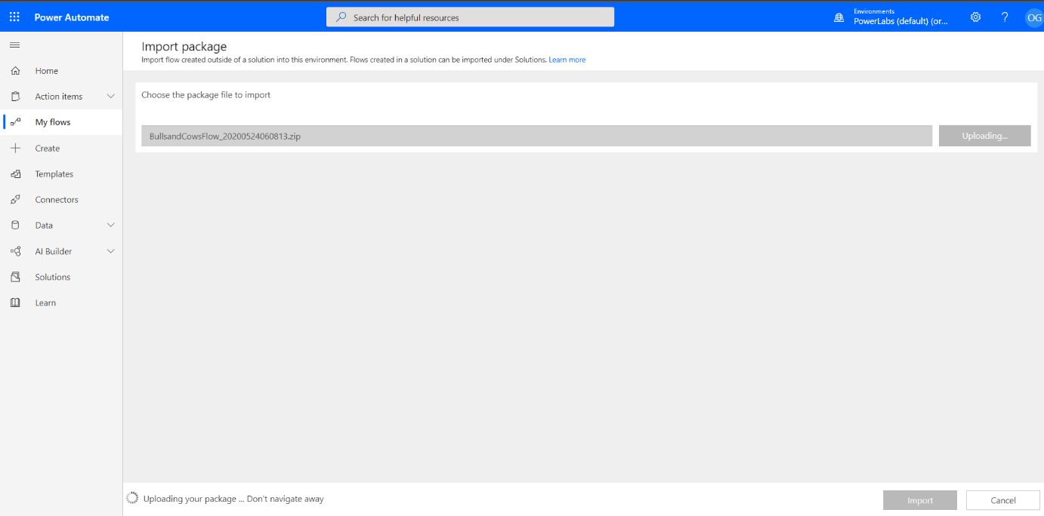

You need to create a connection to Microsoft Teams to get it working.

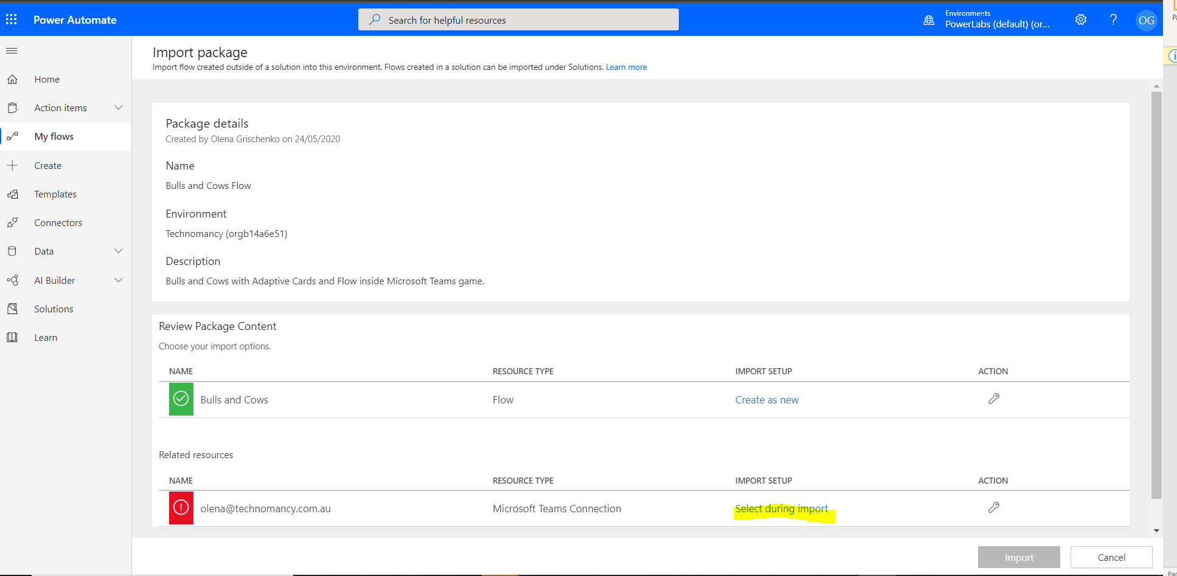

If you don’t have the connection already click on *Create new.*

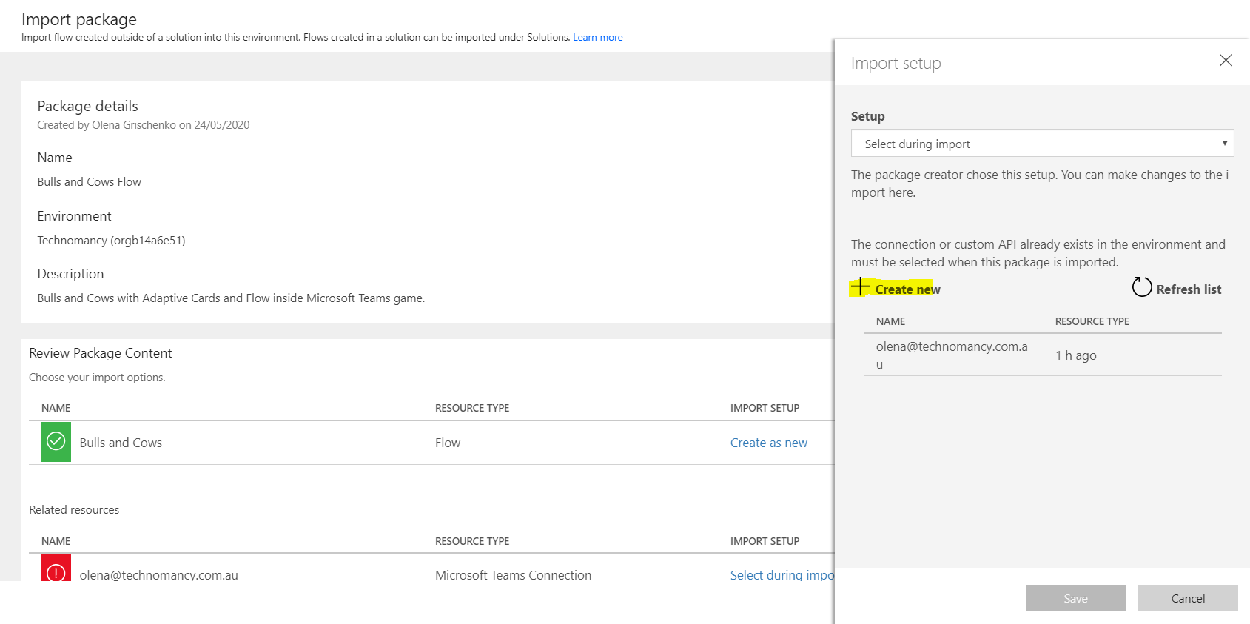

Click on *New connection.*

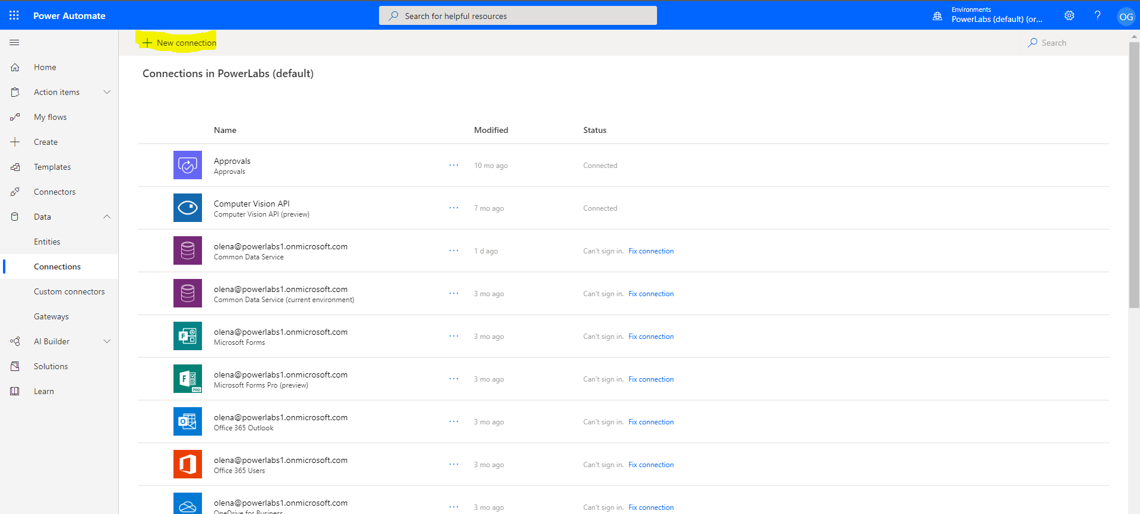

Search for Teams. Select Microsoft Teams connector then click on *+*

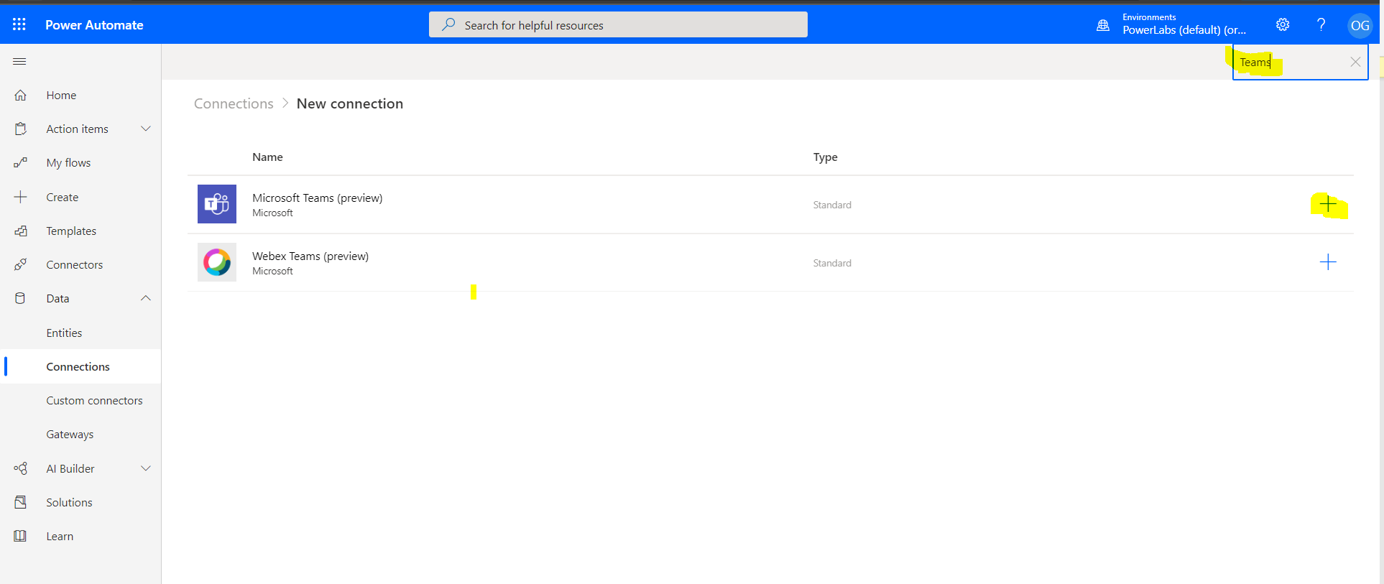

Follow the steps to authenticate and create the connection.

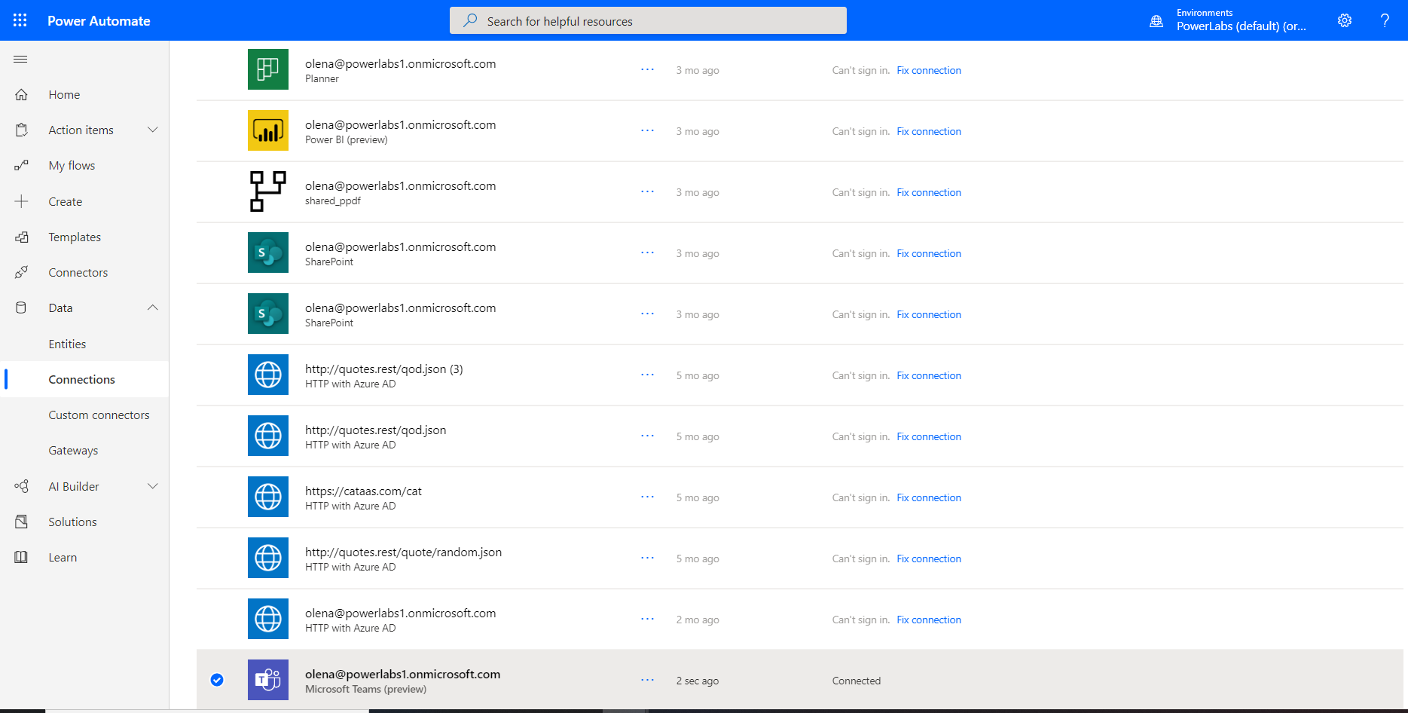

Now you are ready to Import the Flow. Click on the *Import* button.

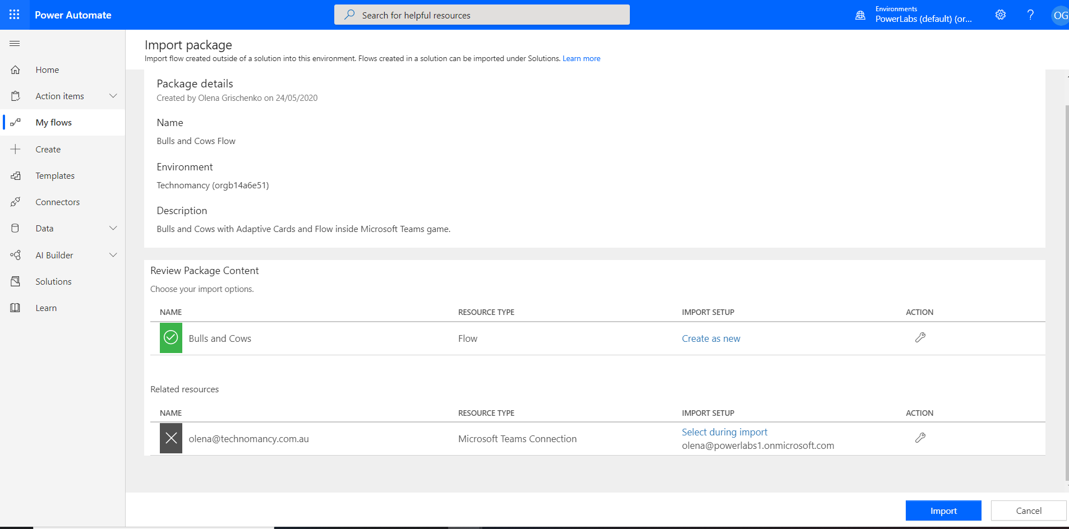

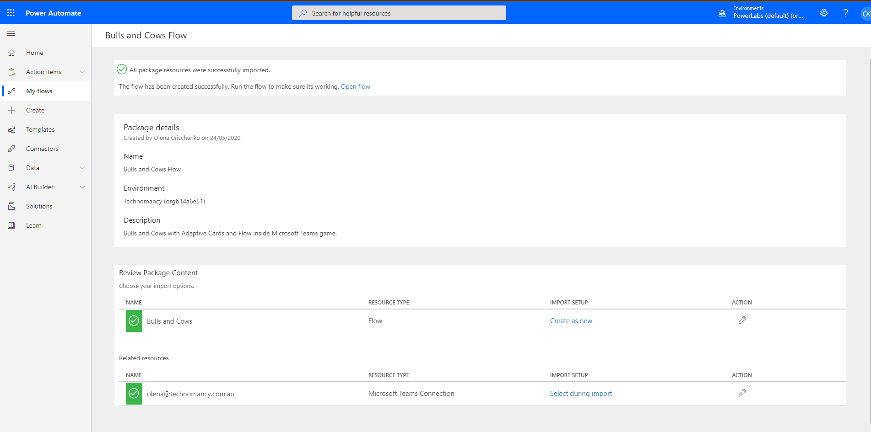

A new Flow should appear in the list of Flows.

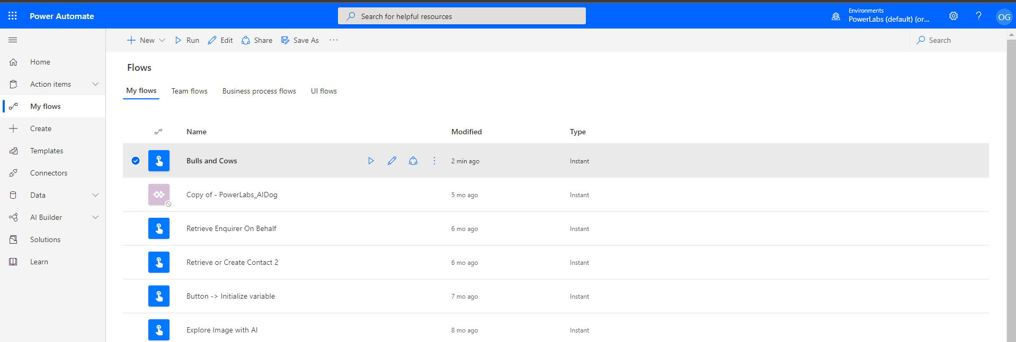

The next step will be to create a new channel inside your Teams to test the Flow.

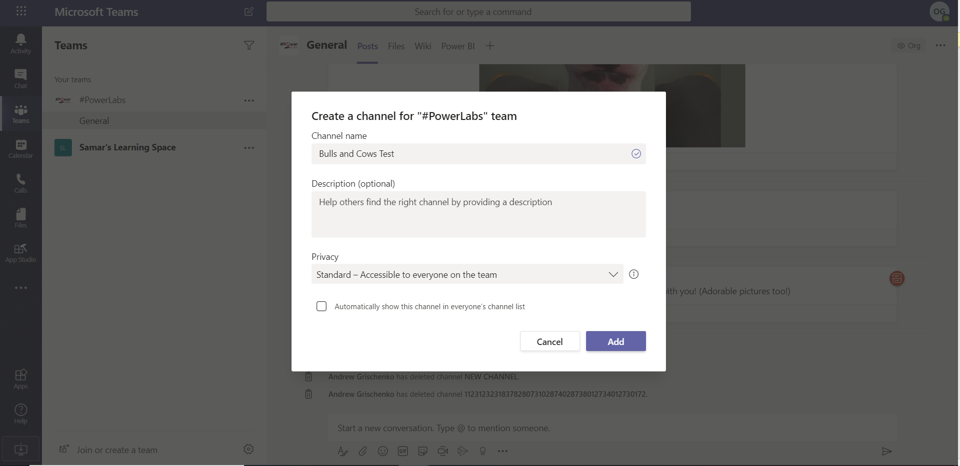

Now you have to open the Flow for Edit and fix all references to Teams and channels for Teams actions (Adaptive cards posts) via replacing it with your Teams and the test channel you just created.

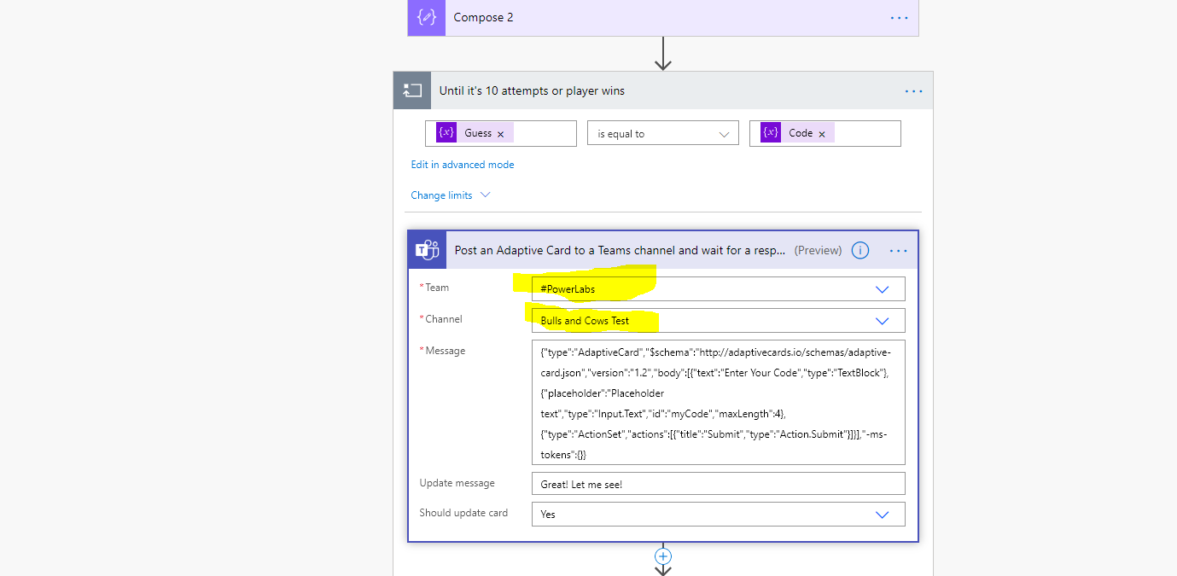

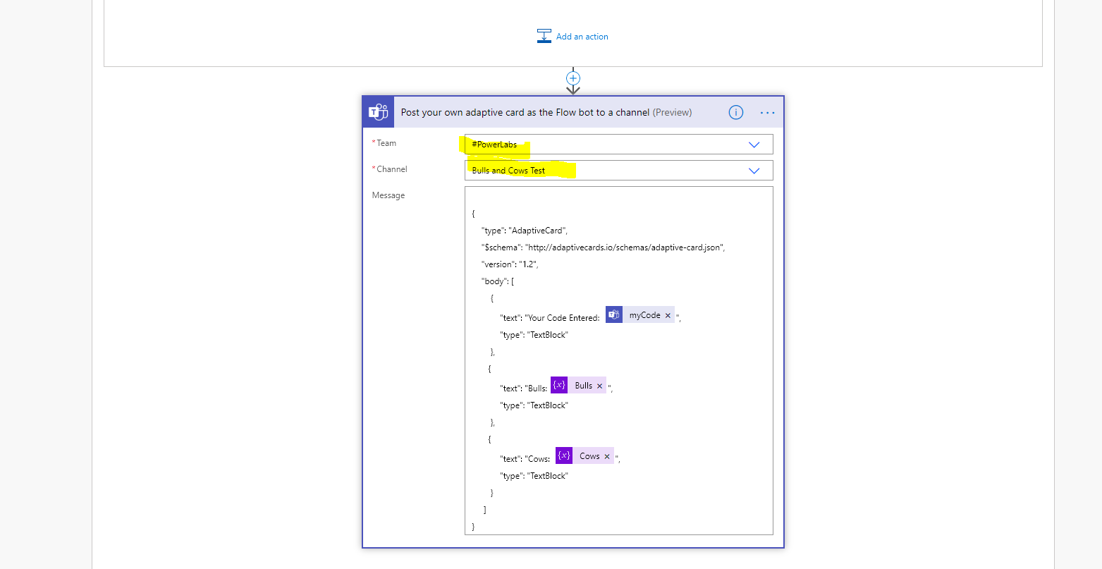

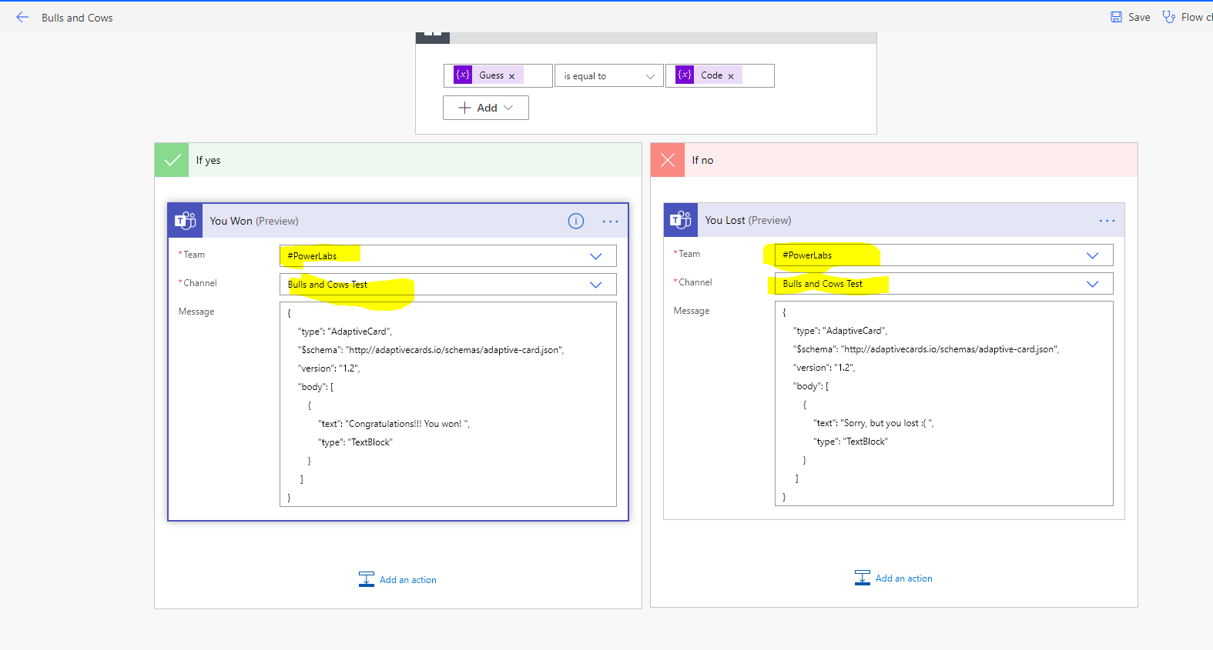

Test Flow by manually runny it. Go to the Teams channel to populate your first Guess attempt. Good luck!

